**DataTable/ Grid**

***DAO MINH DAM  
Email:***[*daominhdam@gmail.com*](mailto:daominhdam@gmail.com)

***Skype:****daominhdam (Đào Minh Đảm)*

[***https://automationfc.vn***](https://www.google.com/url?q=https://www.google.com/url?q%3Dhttps://automationfc.vn%26amp;sa%3DD%26amp;source%3Deditors%26amp;ust%3D1628671032494000%26amp;usg%3DAOvVaw1e_SOKE1yXukkZ9KpJXfpq&sa=D&source=editors&ust=1628671032530385&usg=AOvVaw1gLUI0BK1PM-kpf35Nwlz1)*-*[***https://automationfc.com***](https://www.google.com/url?q=https://www.google.com/url?q%3Dhttps://automationfc.com%26amp;sa%3DD%26amp;source%3Deditors%26amp;ust%3D1628671032494000%26amp;usg%3DAOvVaw27afN1YN-ONAKT9TlWffHG&sa=D&source=editors&ust=1628671032530579&usg=AOvVaw1tVAUMEcNGGEkllsLBWJuR)

***Tài liệu này chỉ sử dụng trong khóa học - vui lòng không chia sẻ công khai***  
-------------------------------------------------------------------------------------------------------------------------------

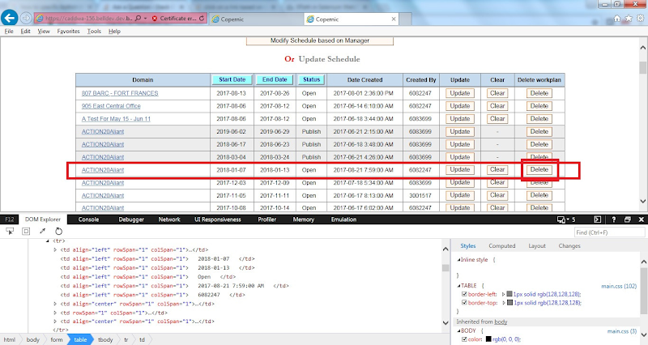

**Site Demo**

* [appendGrid: Data Table Example](https://www.google.com/url?q=https://www.google.com/url?q%3Dhttps://www.jqueryscript.net/demo/jQuery-Dynamic-Data-Grid-Plugin-appendGrid/%26amp;sa%3DD%26amp;source%3Deditors%26amp;ust%3D1628671032495000%26amp;usg%3DAOvVaw0FCbfKKC4m9AJh8BABAoiA&sa=D&source=editors&ust=1628671032531062&usg=AOvVaw20hYVR8olL-Fli_CYXKxLX)
* [QuickGrid: jQuery CRUD Data Grid Demo](https://www.google.com/url?q=https://www.google.com/url?q%3Dhttps://www.jqueryscript.net/demo/CRUD-Data-Grid-Plugin-jQuery-Quickgrid/%26amp;sa%3DD%26amp;source%3Deditors%26amp;ust%3D1628671032495000%26amp;usg%3DAOvVaw3z0w5sQ3RtESyLmQlCZfTf&sa=D&source=editors&ust=1628671032531284&usg=AOvVaw1SE1mgm-j2l1xP9OlazFDW)
* [https://automationfc.wordpress.com/wp-admin/edit.php?mode=list](https://www.google.com/url?q=https://www.google.com/url?q%3Dhttps://automationfc.wordpress.com/wp-admin/edit.php?mode%253Dlist%26amp;sa%3DD%26amp;source%3Deditors%26amp;ust%3D1628671032496000%26amp;usg%3DAOvVaw2HqMCo-Kr4USXX7fSwBbtV&sa=D&source=editors&ust=1628671032531487&usg=AOvVaw2_Gdnl9G4_Pz45VGtVAJqB)
* [http://live.demoguru99.com/index.php/backendlogin/customer/](https://www.google.com/url?q=https://www.google.com/url?q%3Dhttp://live.demoguru99.com/index.php/backendlogin/customer/%26amp;sa%3DD%26amp;source%3Deditors%26amp;ust%3D1628671032496000%26amp;usg%3DAOvVaw03b4gHOXHliBSng3lAQ-Fk&sa=D&source=editors&ust=1628671032531688&usg=AOvVaw18T5WDNOLZxVBedME8wOdC)
* [https://admin-demo.nopcommerce.com/Admin/Order/List](https://www.google.com/url?q=https://www.google.com/url?q%3Dhttps://admin-demo.nopcommerce.com/Admin/Order/List%26amp;sa%3DD%26amp;source%3Deditors%26amp;ust%3D1628671032497000%26amp;usg%3DAOvVaw2z3eQ67ifgNIXI18MO7R04&sa=D&source=editors&ust=1628671032531901&usg=AOvVaw2oJFWxPnQ-R-rdfpjtrN9n)

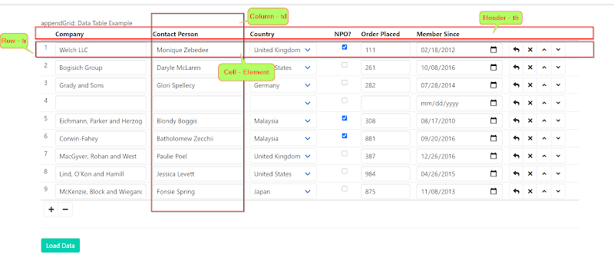

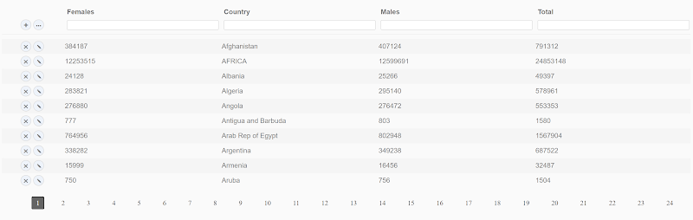

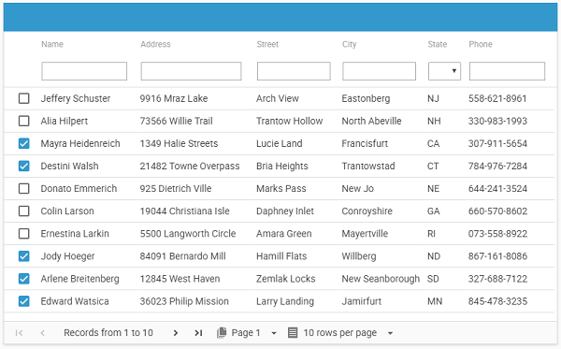

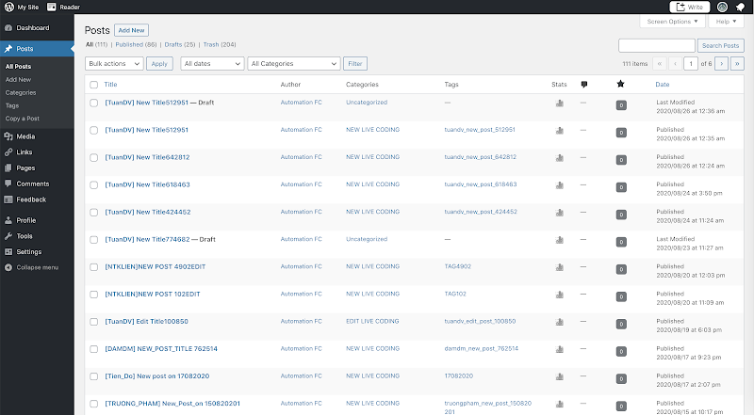

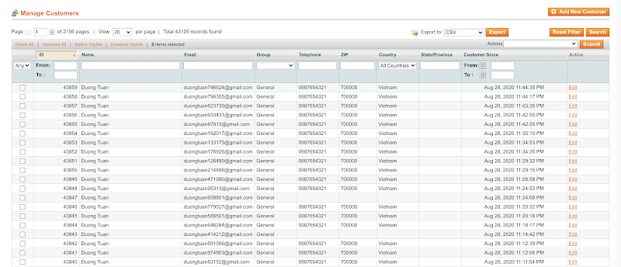

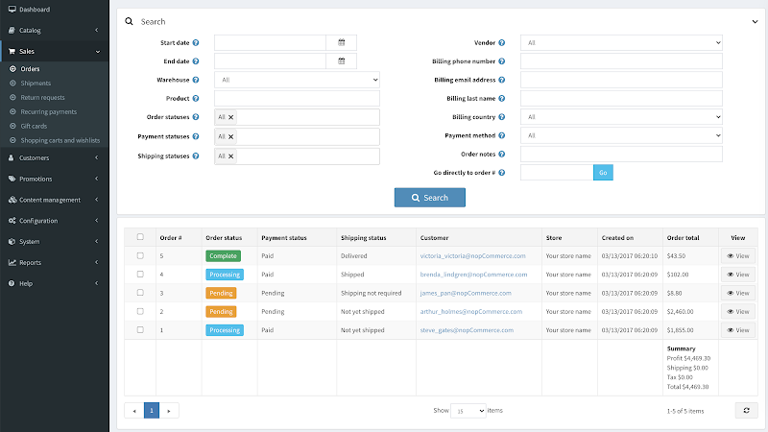

**Xử lí các thao tác trong table/ grid**

* Click vào icon/ button/ checkbox theo row/ column
* Sendkey vào textbox theo row/ colum
* Select giá trị trong dropdown theo row/ colum
* Check displayed

|  |
| --- |
| public void paginationByPageNumber(String pageNumber) {                 String locator = "//li[@class='qgrd-pagination-page']/a[text()='%s']";                 waitToElementVisible(driver, locator, pageNumber);                 clickToElement(driver, locator, pageNumber);         }          public boolean isPageSelected(String pageNumber) {                 String locator = "//a[@class='qgrd-pagination-page-link active' and text()='%s']";                 waitToElementVisible(driver, locator, pageNumber);                 return isElementDisplayed(driver, locator, pageNumber);         }          public void clickEditOrDeleteIconByCountryName(String countryName, String actionName) {                 String locator = "//td[@data-key='country' and text()='%s']/preceding-sibling::td[@class='qgrd-actions']/button[@class='qgrd-%s-row-btn']";                 waitToElementVisible(driver, locator, countryName, actionName);                 clickToElement(driver, locator, countryName, actionName);                 sleepInSecond(2);         }          public String getTotalValueByCountryName(String countryName) {                 String locator = "//td[@data-key='country' and text()='%s']/following-sibling::td[@data-key='total']";                 waitToElementVisible(driver, locator, countryName);                 return getTextElement(driver, locator, countryName);         }          public void sendkeyToDynamicTextboxByRowNumber(String columnName, String rowNumber, String value) {                 // Get index from column name                 String locator = "//th[contains(text(),'%s')]/preceding-sibling::*";                 int index = findElementsByXpath(driver, locator, columnName).size() + 1;                  // Sendkey                 locator = "(//td[" + index + "]/input)[" + rowNumber + "]";                 waitToElementVisible(driver, locator);                 sendkeyToElement(driver, locator, value);         } |

**Lấy ra vị trí (position) của một cột trong table**

* Tương tự như một gia đình có 10 người con - nếu biết người con nào ở vị trí thứ mấy chỉ cần quan tâm người đó có bao nhiêu người anh (preciding-sibling)

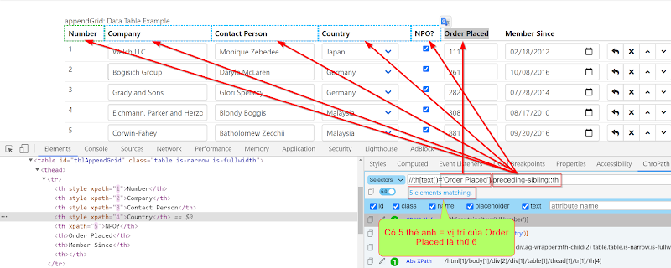

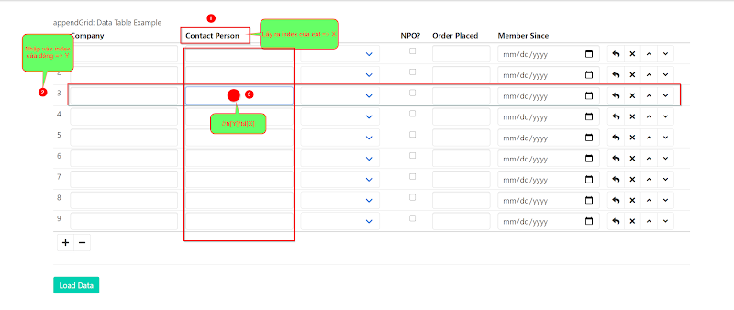

* **Trường hợp nhận tham số của cả cột và hàng**
* Chỉ số đầu ra của cột là chỉ số đầu vào của cell
* Chỉ số đầu ra của hàng là chỉ số đầu vào của cell

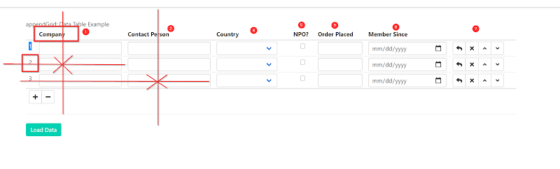

|  |
| --- |
| @Test          public void TC_01_Open_Page() {                 driver.get("https://www.jqueryscript.net/demo/CRUD-Data-Grid-Plugin-jQuery-Quickgrid/");                  // Open page 5                 paginationByPageNumber("5");                 Assert.assertTrue(isPageSelected("5"));                  // Open page 5                 paginationByPageNumber("12");                 Assert.assertTrue(isPageSelected("12"));                  // Open page 5                 paginationByPageNumber("19");                 Assert.assertTrue(isPageSelected("19"));         }          @Test         public void TC_02_Delete_Edit_Icon() {                 driver.get("https://www.jqueryscript.net/demo/CRUD-Data-Grid-Plugin-jQuery-Quickgrid/");                  clickEditOrDeleteIconByCountryName("Afghanistan", "remove");                 clickEditOrDeleteIconByCountryName("Angola", "remove");                 clickEditOrDeleteIconByCountryName("Argentina", "remove");                 clickEditOrDeleteIconByCountryName("Aruba", "remove");                  clickEditOrDeleteIconByCountryName("Australia", "edit");         }          @Test         public void TC_03_Get_Total_By_Country() {                 driver.get("https://www.jqueryscript.net/demo/CRUD-Data-Grid-Plugin-jQuery-Quickgrid/");                 System.out.println(getTotalValueByCountryName("Angola"));                 System.out.println(getTotalValueByCountryName("Argentina"));                 System.out.println(getTotalValueByCountryName("Afghanistan"));                 System.out.println(getTotalValueByCountryName("Aruba"));         }          @Test         public void TC_04_Sendkey_By_ColumnName_At_Row() {                 driver.get("https://www.jqueryscript.net/demo/jQuery-Dynamic-Data-Grid-Plugin-appendGrid/");                                  sendkeyToDynamicTextboxByRowNumber("Company", "2", "Automation FC");                 sleepInSecond(2);                                  sendkeyToDynamicTextboxByRowNumber("Order Placed", "1", "Viet Nam");                 sleepInSecond(2);                  sendkeyToDynamicTextboxByRowNumber("Contact Person", "3", "Dao Minh Dam");                 sleepInSecond(2);         } |

**Flow Demo**

* **Đăng kí tài khoản trang live guru**
* **Qua trang admin kiểm tra User đã đăng kí thành công**